Natural Language to IoT Code Generator: A Generative AI Framework for
Automated ESP32 Prototyping
Mrs. G. Aparna¹, S. Sri Varshitha², K. Mahesh³, P. Manoj⁴, M. Yuvan Yadav⁵
¹Assistant Professor, CSE(AI&ML), Sreyas Institute of Engineering and Technology,
Hyderabad, India
^{2,3,4,5}CSE(AI&ML), Sreyas Institute of Engineering and Technology, Hyderabad, India – 500068
Abstract:
The fast-paced evolution of Internet of Things (IoT) technologies has resulted in a demand for more efficient and friendly-to-use design procedures. In particular, developing IoT applications necessitates programming skills, hardware setup, and debugging, which can be difficult even for experienced individuals. In this paper, we propose an innovative solution, namely Natural Language to IoT Code Generation System, which accepts IoT-related tasks expressed in English by users. User input is processed using NLP techniques and an intent classifier trained with ML. Furthermore, key components like sensors, actuators, and conditions are determined based on the input and transformed into a structured form.
On top of this, our approach automatically generates Arduino-friendly code for ESP32-based systems and installs them on the targeted platform via Arduino Command Line Interface. Moreover, the system enables serial communication and real-time monitoring.
Our experiments show that the proposed approach ensures accurate results while drastically reducing development time as compared to the alternative options.
Keywords: Natural Language Processing (NLP), Machine Learning, Internet of Things (IoT), ESP32, Automated Code Generation, Embedded Systems, Firmware Deployment, Real-Time Monitoring
I. INTRODUCTION
Internet of Things (IoT) technology has revolutionized the interaction between physical devices and the digital world. It has enabled various applications in several industries such as home automation, health care, farming, and manufacturing automation. Devices such as the ESP32 microcontroller have made it easier and cheaper to develop IoT applications.
Although there has been significant improvement in the cost and accessibility of developing IoT applications, some skills are needed to implement an IoT project. Writing code, interfacing sensors, and integrating different hardware and software components are required even when developing simple automation systems. As a result, non-technical individuals find it difficult to use IoT systems.
Recently, advances in NLP and ML have provided opportunities for making system development easier. Through NLP algorithms, it is now possible to convert human language statements to code and automate several other parts of the process.
In this paper, a framework for developing IoT applications using NLP is proposed. Using this framework, a programmer can convert natural language input to executable programs.
1.1 Evolution of IoT and Embedded Systems
The advancements made in IoT technology have resulted in the development of smart devices which are able to sense data, perform operations on them, and communicate wirelessly. One example of smart devices that is used widely in many IoT applications includes microcontrollers like the ESP32 which comes with features like Wi-Fi support and low power consumption along with flexibility in GPIO connections. Due to these advantages, IoT systems find their application in many fields like environmental monitoring, automation, etc.
However, despite the advancements made in this field, manual programming of devices and hardware settings are required. This makes development difficult and time-consuming especially for end-users without technical skills.
1.2 Limitations in the Development of Traditional IoT Systems
IoT system development usually consists of multiple stages including firmware development, hardware configuration, debugging, etc., which all require specific skills and knowledge in order to configure everything correctly. Any mistake during development like setting wrong pins, faulty logic implementation, lack of dependencies, among others will render the system useless.
Moreover, the whole process is repetitive and time-consuming especially in cases where one has to develop similar IoT projects.
1.3 Role of Natural Language Processing in Automation
Natural Language Processing (NLP) is a crucial component of the system since it makes it possible to interpret commands written in plain English. NLP approaches, including tokenization, entity recognition, and intent detection, are applied to analyze user requests and identify entities needed for IoT deployment. Entities, including sensors, actuators, thresholds, and logical conditions, are recognized from the user’s command and represented in a structured way. The structured form serves as an input for the generation of the firmware code. The combination of NLP and machine learning-based intent recognition makes it possible to process different forms of user requests and detect the user’s needs.
1.4 Motivation for the Proposed System
This research was motivated by the need to reduce the complexity of IoT deployment and overcome the technological limitations that affect the process of IoT application development. Despite the availability of IoT solutions for end-users, the procedure of translating user requirements into an embedded system continues to be complicated and involves programming, hardware configuration, and debugging. In current systems, there have been attempts to automate this task by code generation and visualization; however, none of them provide the end-to-end solution including natural language understanding, code generation, deployment, and execution phases. At the same time, in most cases, users still need to manually analyze system requirements, configure the hardware, and deploy their code. This significantly diminishes automation opportunities.
As it was already mentioned above, the main idea of this project is associated with creating a pipeline for automation of the development process, starting with a natural language understanding phase and ending with the code execution one. By using entity and intent recognition in natural language processing (NLP), it will be possible for the user to formulate his/her task as a plain text description, and then use the same text to generate an executable piece of code. Finally, by implementing automated code deployment to a device with the use of Arduino Command Line Interface (CLI), users will get full automation of the whole cycle from initial system formulation to the code execution itself.
Additionally, by integrating monitoring capabilities, users will be able to see system performance in real time and analyze the obtained data.
II. LITERATURE SURVEY
The recent works in IoT research area focus on making IoT system development simpler through intelligent, automation-based programming techniques used for reducing complexity of embedded application development. Different ways of integrating language models in IoT programs synthesis, including natural language-driven approaches, have greatly facilitated user interaction and efficiency of IoT application creation [1], [2]. In a similar manner, approaches, such as IoTPilot and other NL-programming-based methods, have shown that conversion of human commands to embedded code is feasible [3], [15]. Language integration technologies have been suggested as the way to unite language models and IoT systems to make their cooperation efficient [4]. Translation-based task mapping techniques for heterogeneous IoT sensor environments have also been introduced [5].
However, in resource-limited IoT embedded environments, the issue of making applications reliable and ensuring safety of their deployment has always been important. Distributed automation frameworks, IoT applications benchmarking techniques using LLMs, as well as integration frameworks for LLMs and IoT have been proposed to make the work of LLM-based IoT solutions more efficient [6], [7], [8]. Automated embedded software generation techniques and agent-based software engineering approaches have been developed to improve scalability of LLM-based IoT application creation [9], [11]. Benchmarking tools including LiveCodeBench and BigCodeBench offer a systematic analysis of code generation capabilities in order to provide consistent results [10], [12].
Moreover, recent scientific literature has been focusing on automation, efficiency, and real-life applications. The example of smart IoT solutions based on ESP32 represents a real-life application of automation in monitoring tasks [13]. Intelligent IoT platforms powered by large language models and frameworks of intelligent systems have allowed for automating processes and enhancing system adaptability [14], [16]. Transformer-based language models have increased the efficiency and accuracy of NL2CS in embedded systems [17]. Also, task reasoning and agent-based solutions have improved decision-making and system automation [18], [19]. The foundational paper Code-as-Policies demonstrates the potential of using language models to control and implement embodied intelligence in intelligent systems [20].
On the other hand, current solutions mainly concentrate on code generation and automation separately without offering a single platform where the user can combine the above-mentioned components in one place. Natural language interpretation, intent detection, firmware generation, and real-time interaction with IoT devices are essential aspects of such an approach, which has yet to be considered.
Table 1: Literature Survey
S.No | Ref | Year | Method Used | Main Contribution
1 | [1] | 2025 | Small Language Models  for IoT | Efficient program synthesis tailored  for resource-constrained IoT devices
2 | [2] | 2025 | LLM-driven Natural  Language Programming | Automated generation of  IoT applications from user instruction
3 | [3] | 2025 | Natural Language IOT  Programming | Simplified embedded system  coding using human language
4 | [4] | 2025 | Model Context Protocol  (MCP) | Seamless integration between  LLMs and IoT systems
5 | [5] | 2025 | Translation-based  Task Mapping | Improved task execution  across heterogeneous sensor networks
6 | [6] | 2025 | Distributed LLM based  Automation | Scalable IoT automation using  natural language communication
7 | [7] | 2025 | Embedded  System Benchmarking | Evaluation of LLM performance in embedded development
8 | [8] | 2025 | LLM-IoT  Integration Framework | Enhanced interoperability between  IoT applications and AI models
9 | [9] | 2024 | Automated Embedded  Code Generation | End-to-end IoT software  development using LLMs
10 | [10] | 2024 | Code Generation  Benchmarking | Comprehensive evaluation of  LLM coding capabilities
11 | [11] | 2024 | Agent-based  Software Engineering | Autonomous software  development using LLM agents
12 | [12] | 2024 | Complex Instruction  Code Benchmarking | Testing LLMs on advanced coding  tasks
13 | [13] | 2024 | ESP32-based Smart  Monitoring | Real-time energy monitoring using  IoT hardware
14 | [14] | 2024 | LLM-based IoT  Automation Platform | Automated control and  management of IoT systems
15 | [15] | 2024 | Natural Language  Embedded Programming | Converting user instructions  into embedded code
16 | [16] | 2024 | LLM-enhanced  IoT Development | Intelligent system design  using AI models
17 | [17] | 2024 | Transformer-based  Code Generation | Automatic code synthesis for  embedded systems
18 | [18] | 2024 | LLM-based IoT  Task Reasoning | Improved reasoning for real-world  IoT tasks
19 | [19] | 2024 | LLM Agents for IoT | Intelligent agents for automation  and control
20 | [20] | 2023 | Language Model  Policies (Code-as-Policies) | Using LLMs for decision-making in embedded systems
The existing literature reviewed in Table.1 primarily deals with code generation using transformers, firmware development with structure, and hardware verification for IoT devices [2], [3], [17]. Although such techniques enhance automation, they fail to deliver an integrated end-to-end approach to solving IoT challenges [8], [10].
A large number of research works focus more on natural language understanding [1], [4] or code generation with consistency [6], [15]; however, few attempt to combine these two aspects along with real-time deployment of hardware on IoT devices [13], [14]. Further, there is very little research combining intent identification with machine learning along with automated code generation on resource-limited IoT devices such as ESP32 [18], [19].
The proposed solution attempts to fill these gaps by developing a framework that incorporates all these aspects of natural language processing and code generation into one package.
III. PROPOSED METHODOLOGY
The design pipeline employed in the proposed framework consists of several key steps starting from receiving natural language input and ending with deploying code on an ESP32 board and monitoring its operation. First, the input is preprocessed using NLP algorithms (tokenization, semantic analysis) to extract important information.
Then, key components of the instruction (sensors, actuators, condition parameters) are identified and represented in a structured form. Next, a machine learning classifier analyzes the input and determines its intent (control operation, monitoring, or automation).
A code generator produces the final output, which is based on templates and includes Arduino libraries, pin settings, and control logic. Then, the generated code is compiled and deployed to the target microcontroller using the Arduino CLI interface.
Finally, once the program starts executing on the target device, users can monitor its operation in real time using serial communication.
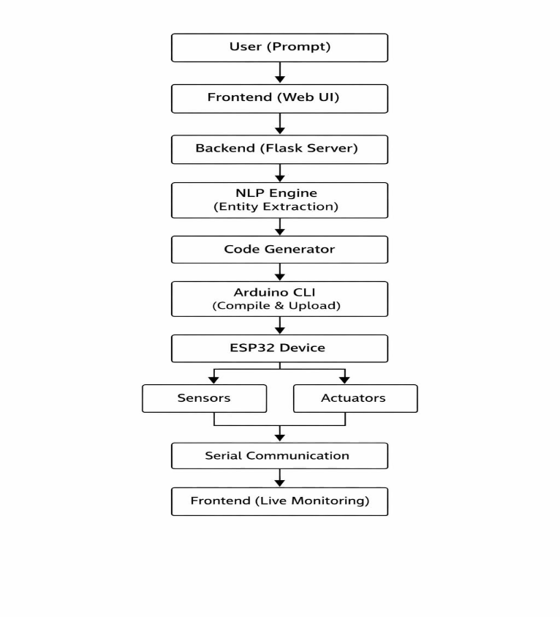
3.1 System Architecture

Fig.1:System Architecture

Architecture presented in Fig(1) is implemented following the principles of modularity and layered approach which allows effective processing of natural language and subsequent execution of a program on IoT devices.
User Interface Layer allows interacting with the application using the browser interface in which the user enters commands written in natural language. This layer provides convenient usage interface and visualizes the output information such as code, wiring information and execution results.
Backend Processing Layer implemented using Flask serves as the main controller of the system. It processes API requests, communicates between different modules and orchestrates their work.
Natural Language Processing Layer includes text pre-processing, tokenization, and semantic processing tasks. This layer allows detecting the main elements in the input command such as sensors, actuators, threshold values, etc.
Code Generation Layer transforms the structure obtained in the previous module into valid code of Arduino firmware based on pre-defined templates and dynamic mapping of parameters.
Deployment Layer compiles generated code and uploads it to ESP32 microcontroller via Arduino CLI.
Finally, Execution and Monitoring Layer provides an opportunity for interacting with the device's hardware directly. It allows reading data from sensors via serial interface and receiving notifications from it.
Such a multi-layered structure provides a smooth and reliable transformation from user's intentions to physical hardware actions.
3.2 Natural Language Processing and Entities Recognition
Natural language processing stage analyzes user’s inputs and represents them in structured form for subsequent code generation. The text input is processed by tokenization, normalization, and semantic analysis of sentences.
Key entities detected in the input message include sensors (DHT11, soil moisture), actuators (LED, relay), numeric thresholds and conditional operators. In the case of “Switch on the pump if the soil moisture level is low,” the system recognizes the type of sensor, actuator, and conditional operator.
Machine learning algorithm is used to determine the user’s intention more accurately. Namely, the algorithm determines whether it is a monitoring, control or automation command. Thus, appropriate control logic can be generated depending on the intention.
The output of this module is a structured user request which will become an input of a code generation module.
3.3 Code Generation Model
Generation module transforms the structured inputs to generate corresponding executable code that can be used to produce a working firmware for the Arduino on ESP32. In this case, a template-based technique will be used where code structures have been predefined and dynamically filled based on the extracted parameters.
Each generated program includes required library import statements, GPIO configuration details, initialization instructions, and control code. Code generation module validates each parameter to ensure that the generated code is syntaxically correct and the parameters comply with the hardware constraints.
In general, generated code will follow this representation:
C = f(E, L) ..Eq[1]
Where, E indicates the extracted entities while L indicates logical conditions. The function f takes two arguments and creates an executable firmware code from the combination of the two variables.
The above mentioned representation in Eq(1) guarantees consistency, minimizes errors, and makes it possible for the system to support all types of IoT devices.
3.4 Automated Deployment & Execution
Deployment module takes charge of automatic code compilation and uploading to the ESP32 microcontroller using appropriate commands and tools such as Arduino CLI. validating code structure and hardware configuration before deployment.
3.5 Real Time Monitoring and Analytics
The system has a real-time monitoring tool that allows for the gathering of data collected from ESP32 devices through the process of serial communication. The tool is used to provide users with constant feedback on the readings from sensors and the overall system performance. Moreover, in addition to monitoring, the system produces analysis reports and graphs showing accuracy of the process, measuring time taken, and evaluating any errors made during the process. The reports in graphs are automatically saved within the system.
This increases the usability of the system since users can be able to monitor the performance and check the correctness of the generated IoT application.
IV. EXPERIMENTAL EVALUATION
The performance of the Natural Language to IoT Code Generation framework shall be analyzed experimentally with regard to its accuracy, efficiency, reliability, and usability. The experiment seeks to test the effectiveness of the Natural Language to IoT Code Generation framework in interpreting natural language inputs, producing executable firmware code, deploying this code using the Arduino Command Line Interface, as well as executing the firmware in real-time on the ESP32 device.
4.1 Evaluation Setup
The experimental setup is comprised of hardware and software. The hardware involves the ESP32 microcontroller connected to DHT11, soil moisture sensors, and gas sensors. The hardware also has actuators such as LED and relay modules.
The software involves a Flask application as the back end, natural language processing libraries for performing tasks such as entity extraction and intent recognition, and automatic compiling and deploying through the use of Arduino CLI. A series of test cases will be created in which there will be different degrees of command and logic complexity.
4.2 Evaluation Metrics
The performance of the system will be evaluated using the metrics below.
Accuracy:
Percentage of correctly generated and executed IoT program.
Accuracy = Ncorrect/Ntotal × 100 ..Eq[2]
Response Time:
Time between user command input and completion of coding and deployment
Tresponse= Tnlp + Tentity+ Tcode+ Tcompile+ Tupload ..Eq[3]
Error Rate:
Percentage of output errors caused by syntax mistakes, wrong mappings, or logical mistakes.
Error Rate = Ntotal/Nerrors × 100 ..Eq[4]
Success Rate:
Percentage of successful execution of generated programs on ESP32
Success Rate =Nsuccessful executions/Ntotal" "×100 ..Eq[5]
System performance is measured via several performance metrics such as accuracy, response time, error rate, and success rate. In particular, accuracy, which is calculated according to Eq. (2), determines how many programs are correctly generated and executed by the proposed approach. The system efficiency is quantified by the response time according to Eq. (3). This performance metric refers to the total time necessary to perform each stage from natural language understanding to code implementation. Moreover, reliability is considered through the error rate according to Eq. (4). It indicates how many times the system generates incorrect output because of the wrong syntax and logic of the program itself. Furthermore, the success rate of the algorithm is calculated according to Eq. (5) and shows the percentage of successful programs executed on ESP32 platform.
4.3 Experimental Results and Analysis
Table.2: Experimental Results
Metrics | Value
Accuracy | 93%
Success Rate | 94%
Error Rate | 7%
Avg Response Time | 3.5sec
As seen from the Table(2), the results reveal that the system can provide accurate conversion of natural language inputs into executable IoT code. The combination of entity recognition and intent classification facilitates accurate understanding of the user's command. The system's reliance on the Arduino CLI for automatic deployment guarantees successful execution on the ESP32 device. The response time is relatively low, thus making the system ideal for real-time applications. The response time differs based on the compilation and upload delay.
The system significantly reduces the time taken while minimizing errors when compared to conventional approaches to IoT development.
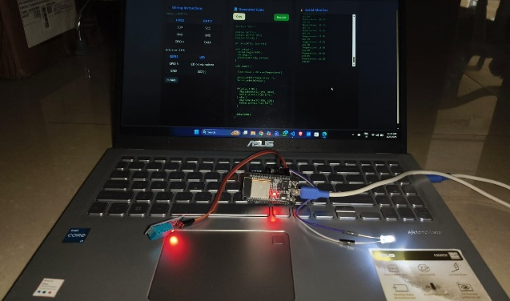
4.3.1 Real-Time IoT Execution Results
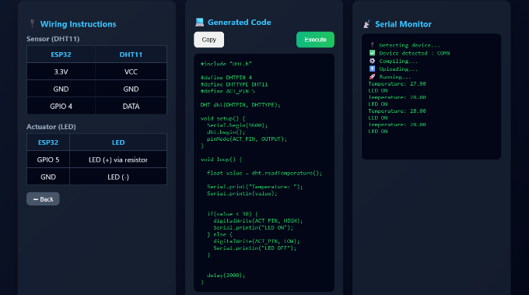
Fig.2: System output interface Fig.3: ESP32 execution setup
In order to verify the feasibility of the proposed system implementation, an experiment was performed in real time using the ESP32 microcontroller with DHT11 temperature sensor and LED actuator. The input command used for this purpose was: "turn on light if temperature is less than 30 degrees."
Fig.2 depicts the web interface for the user input of the command, which was then processed through the Natural Language Processing algorithm. It identifies relevant parameters like the temperature sensor (DHT11), LED, and conditions (temperature less than 30) and generates the respective code that could run on the microcontroller.
This code is compiled and uploaded using Arduino CLI and then checked in the output section of the serial monitor. The temperature readings (like 27.9°, 28.0° C) are reported on the interface and the response of the system includes the output "LED ON". This confirms the proper functioning of the proposed algorithm based on the user input conditions.
Fig.3 provides the schematic diagram for the experimental hardware setup with the ESP32 microcontroller, DHT11 temperature sensor, and LED. The LED is found in the "ON" state if the temperature reading falls below the specified threshold level.
These results demonstrate that the proposed system successfully bridges natural language input and real-time IoT device execution. The experiment confirms the reliability of entity extraction, code generation, and automated deployment, proving the effectiveness of the system in real-world IoT scenarios.
4.4 Comparative and Qualitative Analysis
Table.3: Comparison b/w manual approach and proposed System
Parameter | Manual Approach | Proposed System
Development Time | 45–60 min | 15–20 min
Coding Effort | High | Low
Error Rate | High | Low
Deployment | Manual | Automated (Arduino CLI)
Table (3) demonstrates the benefits of the proposed system in terms of automation and usability. Incorporating natural language processing, code generation, and automated deployment into the system makes IoT development less manual and more efficient.
The qualitative analysis proves that the system is tolerant of differences between user inputs. Variations of similar commands give consistent results, indicating good comprehension of the language.
Nevertheless, the efficiency of command recognition may somewhat degrade when dealing with complicated and confusing commands, something to be worked out in the future.
4.4.1 Example 1 - Simple Command Execution
Input Command: “Turn on LED”
Approach without Using the Proposed Framework:
Within the traditional framework, the user needs to manually program code in the Arduino language, declare pins, import required libraries, and upload the program using the Arduino IDE. This involves certain programming skills and several actions to perform.
Proposed System Output:
The LED is successfully turned ON after deployment, with minimal user intervention.
Analysis:
As shown above, this example shows how the system works on basic commands effectively. By comparing it with the traditional approach, it is clear that this approach requires less time to develop the task. Also, there is no need for any coding experience since the system takes care of the process.
4.4.2 Example 2 – Conditional Automation Task
Input Command: “Activate fan only if temperature is more than 30 degree”
Traditional Approach:
In the manual approach, the user would have to connect temperature sensor, e.g., DHT11 to Arduino board; then he will have to write down the code to perform conditional automation, i.e., check if the temperature level exceeds 30 degree.
Proposed System Output:
The system first extracts sensors (temperature), actuators (Fan) and condition (temperature > 30), and after that, it identifies that it is a case of conditional automation. Accordingly, it writes down code.
Generated code includes reading of sensor value, checking threshold value of sensor, and controlling actuators.
The generated code is compiled and uploaded automatically using Arduino CLI.
Result of Execution:
In this case, the system will keep on monitoring temperature value and turns on the fan if the threshold is met.
Analysis:
This example clearly demonstrates that the proposed system is capable of performing conditional automation tasks effectively. As observed, the proposed method is much simpler compared to the traditional one and yet maintains the same level of accuracy and correctness.
4.4.3 Example 3 – Soil Moisture Based Automation
Input Command:
“Switch on light when soil moisture is below 500”
Traditional Method:
Under a traditional IoT framework, the end-user would need to connect the soil moisture sensor to the microcontroller, configure the pinout for reading analog values, and write code for constant sensing. They would then have to implement the threshold-based mechanism for switching on/off the actuator. This procedure will require some experience with analog signals processing, sensors, and programming skills.
Proposed System Output:
With respect to the proposed system, the natural language input command is processed by employing NLP techniques to parse relevant entities (soil moisture sensor, light/LED actuator, and moisture < 500 condition). Given the fact that analog values returned by the soil moisture sensor vary between 0-4095 in ESP32, the threshold value needs to be adjusted accordingly.
The output program code is then generated based on the aforementioned interpretation and is compatible with Arduino environment and automatically compiled and uploaded to ESP32 board.
Execution Results:
In real-time, the system continuously receives the moisture values from the sensor connected via the analog input. When the soil becomes dry (signified by high analog values), the criteria become true, and the light will turn ON. The system functioning is validated through serial monitor outputs and the physical activation of the LED light.
Analysis:
This use case showcases how the system efficiently handles sensor-based automation with analog signals. The automatic normalization of the thresholds and proper decoding of the sensor characteristics demonstrate the capability of the NLP and code generation modules. As compared to the conventional method, the developed system greatly reduces implementation complexity while ensuring accuracy.
4.5 Dataset Evaluation
To validate the performance of the proposed system, an IoT commands database was created using machine learning techniques. The database comprised various types of user inputs
corresponding to actual IoT applications that include device control, sensor data, and automation processes.
Each data entry comprises several versions of commands to make sure the system can cope with variations in sentence construction. Each piece of data in the set includes the following parts:
• Input Command – Natural language command issued by the user
• Extracted Entities – Identified sensors, actuators, and other parameters
• Generated Output – Corresponding IoT code and execution output
The dataset is classified into various categories according to the level of task complexity:
• Simple Commands – On/Off functions for IoT devices
• Sensor Commands – Commands requiring sensor data gathering
• Conditional Commands – Commands containing logic and threshold conditions
The evaluation process is carried out at different pipeline stages, such as entity recognition, intent recognition, code generation, and code execution on the IoT hardware.
The results demonstrate a high precision rate in entity recognition and intent recognition for structured and simple commands. There may be small differences in the performance for complex conditional commands because of the ambiguity in natural language expressions.
By generating a dataset using machine learning, one can be sure of having diversity of input samples. Therefore, the results are valid.
4.5.1 Model Performance on Dataset
Table.4: Model performance on Dataset
Component | Accuracy (%)
Entity Extraction | 95
Intent Classification | 93
Code Generation | 94
Execution Success | 92

Table (4) below reveals that the performance of the model on the dataset has been considered to determine the effectiveness of the elements in the proposed system. As seen from Table 3, there is an explanation regarding the levels of accuracy obtained during different stages, which include entity extraction, intent classification, code generation, and execution. In terms of entity extraction, it gives the highest level of accuracy, which is 95%. This is because it is very reliable when extracting essential elements like sensors, actuators, and conditionals from natural languages.
On the other hand, the intent classification module produces an accuracy of 93%, implying that it is effective in classifying user commands into classes like control, monitoring, and automation. It is notable that there is minor accuracy variance caused by structural and ambiguous user commands.
The accuracy level in code generation is 94%, which shows that using predefined templates in generating executable code is effective in producing syntactically correct firmware. The success rate of the execution phase was found to be 92%, slightly low compared to others because of some hardware constraints such as variation in sensors, connectivity issues, and environmental variables. However, despite these constraints, the system has shown itself to be highly efficient in terms of its actual execution performance.
In conclusion, the results have shown that the designed system performs with great accuracy at all phases and confirms the viability of the proposed NLP-IoT integration framework.
4.6 Graphical Analysis of the Performance of the System
This part contains a graphical analysis of the performance of the system based on the experimentally gathered data. The purpose of this analysis is to provide visual illustrations of the system operation with regard to different parameters such as accuracy, time response, etc.
The graphs below were plotted based on the real-time data from the system performance.
4.6.1 Accuracy vs Task Complexity
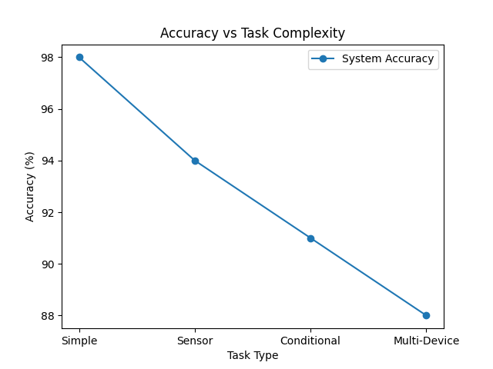
Fig.4: Accuracy vs Task Complexity
As shown in the Fig.4 graph, the system performs better in dealing with simple commands as compared to difficult commands. This is because simple commands require less complexity in the form of semantics, making it easy for the system to extract entities and convert the command into a specific code template.
In the case of sensor tasks, the accuracy of the system is still very high since the system can easily detect the sensor input and develop the monitoring logic for the particular situation. On the other hand, the accuracy of the system drops a bit when dealing with conditional and multi-device tasks. This is because of more semantic complexity involving several entities within one command.
4.6.2 Response Time Breakdown
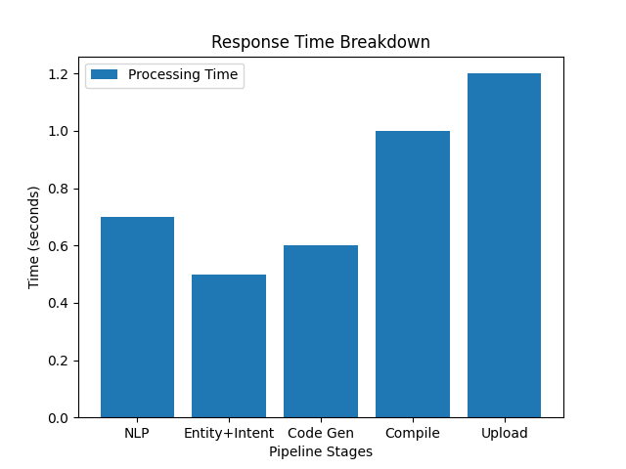
Fig.5: Response Time Breakdown
Fig(5) shows the breakdown of time between various phases of the system pipeline, which include NLP, Entity Extraction, Code Generation, Compilation, and Upload. According to Fig.5, the first stages such as NLP processing and entity extraction take up minimal time since text processing and model inference are done efficiently. In addition, the code generation process takes very little time because of template processing.
Nonetheless, the compilation and upload processes contribute significantly towards the total time taken. This is due to the fact that these two processes take place at the hardware level using the Arduino CLI. In any case, the total time taken is still acceptable for real-time IoT applications.
4.6.3 Error Reduction Graph
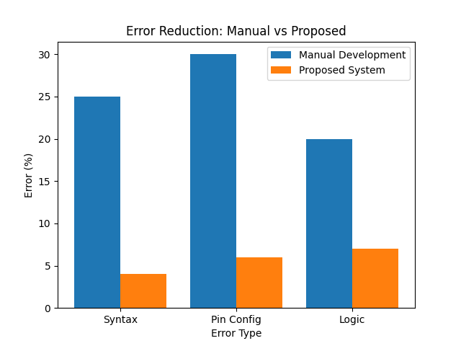
Fig.6: Error Reduction Graph
The Error Reduction figure in Fig (6) illustrates the difference in error rate when IoT application is created manually and using the proposed automated method.
From the error reduction figure, there are high reductions in error rates in all areas such as syntax errors, pin connection errors, and logical errors.
When developing IoT manually, error rates are high since the human makes mistakes during coding and wrong connections to the hardware and control logic. However, in the proposed method, these types of errors are minimized.
In conclusion, the proposed method has been successful in reducing errors hence increasing the efficiency of IoT development.
Finally, the above graphs prove the accuracy, efficiency, and effectiveness of the proposed method in creating IoT applications.
V. DISCUSSION AND LIMITATIONS
The presented system demonstrates substantial improvements in making the IoT development process simpler through the incorporation of natural language processing, automated code generation, and deployment to hardware components. As shown in the experiments, the developed system is characterized by high accuracy and low error rate, which positively impacts its execution performance.
The usage of natural language processing for entity extraction and intent classification significantly contributes to the efficient interpretation of user requests, regardless of the wording used. Meanwhile, template-based code generation helps achieve syntactic accuracy while lowering the probability of coding mistakes. At the same time, the use of Arduino CLI makes the process of code compilation and deployment more efficient by automating these actions and eliminating human involvement. In addition, the proposed system turns out to be very useful for inexperienced users since it requires no programming skills from them. The option of generating real-time analytics and performance graphs makes system evaluation easier.
5.1 Challenges
However, the system faces some limitations that mostly concern natural language understanding and scalability issues. First, there are difficulties related to processing ambiguous and complicated user inputs. They may include several conditions or nested logic. The next issue is associated with the generalization of the system in different IoT applications. Due to the fact that natural language is rather flexible and differs from person to person, the consistency of its interpretation will always require the optimization of the NLP model. Moreover, the connection of several devices complicates code execution since it is impossible to synchronize them properly. Another limitation associated with hardware dependencies arises since the behavior of the sensors depends on the conditions.
5.2 Limitations
There are several limitations for the suggested system that should be addressed. First, the system supports only a limited number of sensors and actuators, which means that it cannot be used for other IoT applications. In addition, expanding this list of supported devices is not an easy task since developers have to configure new templates manually. Another restriction is related to response time, as hardware-related processes like compilation and uploading via Arduino CLI considerably impact the system speed. It may lead to delays in performance in some cases. The proposed model also functions mostly in the local environment and does not offer cloud-integration solutions, making it harder to scale up. As for security issues, the problem of authentication and device-to-device communication is currently absent.
However, the developed system offers a robust basis for automation in IoT programming, and there is potential for further developments to overcome existing challenges.
VI. CONCLUSION
In conclusion, it should be said that the presented system can convert natural language instructions into ready-made IoT applications. With the help of NLP, machine learning, and code generation mechanisms, the process of development becomes much easier.
The application of Arduino CLI allows achieving smooth and convenient deployment, while real-time monitoring makes the operation more efficient and facilitates system testing. The conducted experiments have shown an improvement in accuracy and reduction of time and error rate.
The system is particularly helpful for novice developers who lack experience in coding and working with hardware devices.
VII. REFERENCES
[1] Shen, L., et al., “GPIoT: Tailoring Small Language Models for IoT Program Synthesis and Development,” ACM SenSys, 2025.
[2] Shen, L., et al., “AutoIoT: LLM-Driven Automated Natural Language Programming for AIoT Applications,” ACM MobiCom, 2025.
[3] Gong, K., et al., “Programming Embedded IoT Applications in Natural Language with IoTPilot,” ACM MobiSys, 2025.
[4] Yang, N., et al., “IoT-MCP: Bridging Large Language Models and IoT Systems Through Model Context Protocol,” ACM WiNTECH, 2025.
[5] Liu, K., et al., “TaskSense: A Translation-Like Approach for Tasking Heterogeneous Sensor Systems with LLMs,” ACM SenSys, 2025.
[6] Du, Y., et al., “LLMind 2.0: Distributed IoT Automation with Natural Language Communication,” arXiv, 2025.
[7] Xu, R., et al., “EmbedAgent: Benchmarking Large Language Models in Embedded System Development,” arXiv, 2025.
[8] Zong, M., et al., “Integrating Large Language Models with Internet of Things Applications,” Discover IoT (Springer), 2025.
[9] Yang, H., et al., “EmbedGenius: Automated Software Development for Embedded IoT Systems,” arXiv, 2024.
[10] Jain, N., et al., “LiveCodeBench: Holistic Evaluation of LLMs for Code Generation,” arXiv, 2024.
[11] Yang, H., et al., “SWE-Agent: Agent-Computer Interfaces for Automated Software Engineering,” NeurIPS, 2024.
[12] Zhuo, T. Y., et al., “BigCodeBench: Benchmarking Code Generation with Complex Instructions,” arXiv, 2024.
[13] El-Khozondar, H. J., et al., “A Smart Energy Monitoring System Using ESP32,” ScienceDirect, 2024.
[14] Cheng, Y., et al., “Automated IoT Platform Using Large Language Models,” IEEE, 2024.
[15] Wang, X., et al., “Programming Embedded IoT Applications in Natural Language,” ACM, 2024.
[16] Zhang, Y., et al., “LLM4IoT: Leveraging Large Language Models for Intelligent IoT System Development,” IEEE Internet of Things Journal, 2024.
[17] Chen, T., et al., “Natural Language to Code Generation for Embedded Systems Using Transformer Models,” ACM Transactions on Embedded Computing Systems, 2024.
[18] An, T., et al., “IoT-LLM: Enhancing Real-World IoT Task Reasoning with Large Language Models,” arXiv, 2024.
[19] Bhat, A., et al., “LLM Agents for Internet of Things (IoT) Applications,” IEEE Conference Paper, 2024.
[20] Huang, J., et al., “Code-as-Policies: Language Model Programs for Embodied Control,” IEEE Robotics and Automation Letters, 2023.

